**OOAD with java 2025**

**FCSE24-011**

**Katlego poifo**

**System User Case Diagrams**

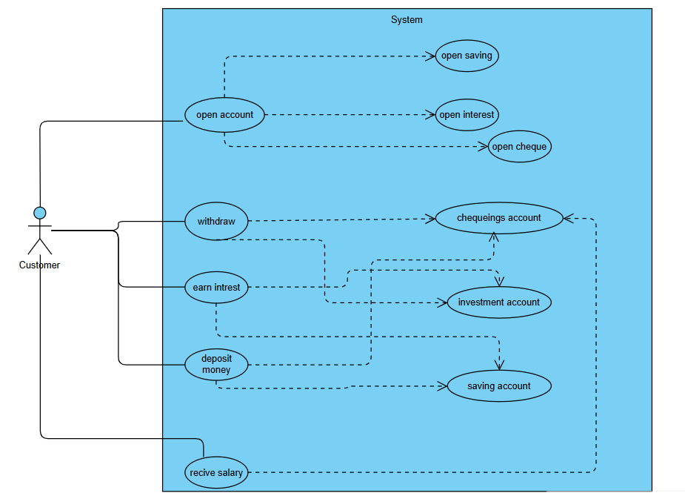

**Bank system Class Diagrams**

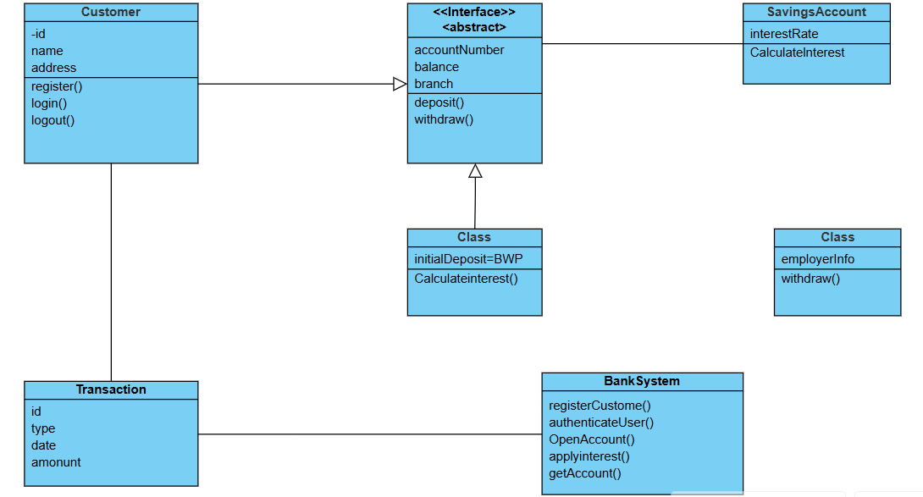

**Sequence Diagrams**

**Login Sequence Diagrams**

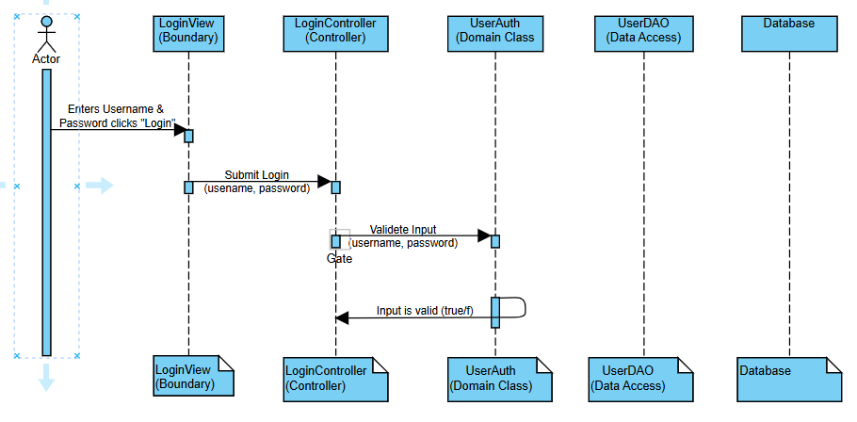

**Deposit Sequence Diagrams**

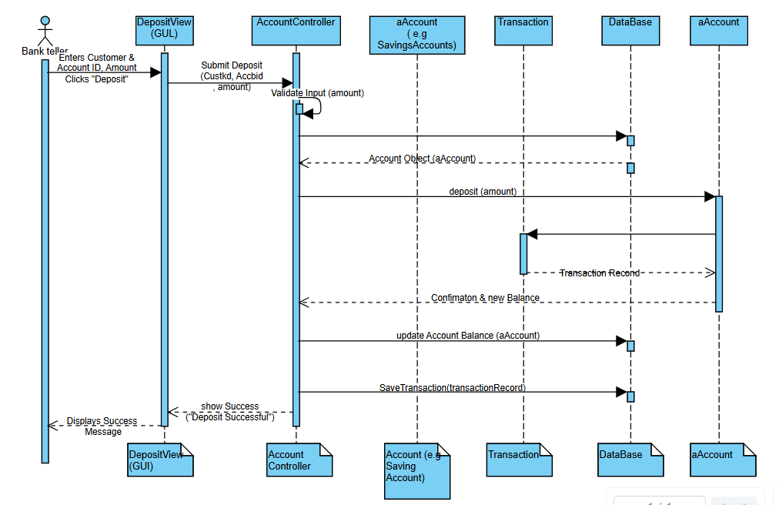

**State Diagrams**

